3.2 Law of Sines

Oblique Triangle
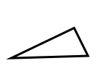

The Sine Law

A triangle has angles measuring 80° and 55°. The side opposite the 80° angle is 12m in length. Determine the length of the side opposite the 55° angle.

Find the measure of angle B in the diagram below:
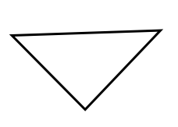

A 12 km B

9 km

80°

C

