4.1 Review and Preview (continued)

Function –

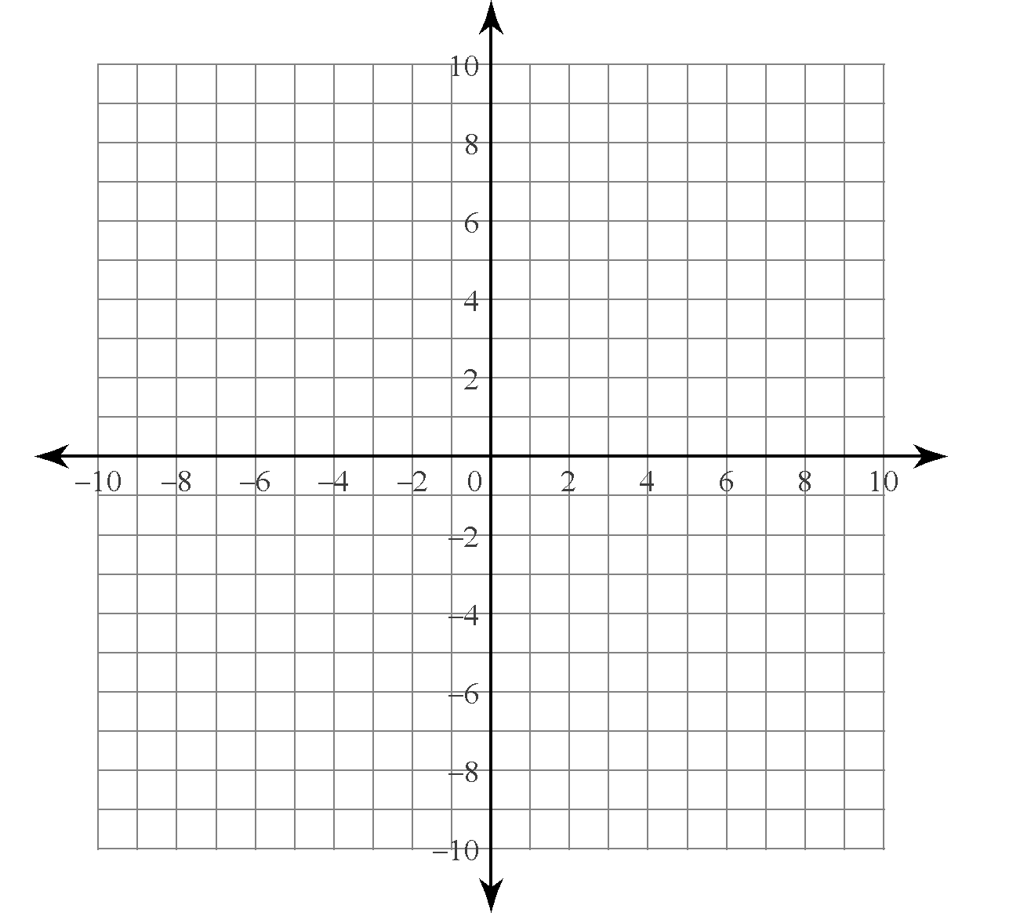
Inverse of a Function –

Determining the Inverse of a Relation or Function

Graph the function $y=\sqrt{x-2}$ and its inverse on the same grid. What is the equation of the inverse of the function?

What is the inverse of the function defined by $y=\frac{2}{5}x+6$?

