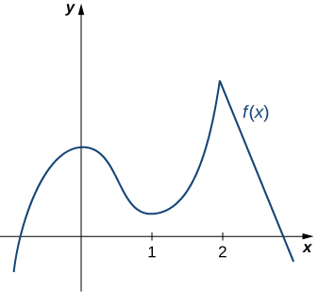**4.2 Maximum and Minimum Values**

A function *f* has an **Absolute Maximum / Global Maximum** at *c* if

A function *f* has an **Absolute Minimum / Global Minimum** at *c* if

The **Extreme Values** of *f* are

A function *f* has a **Local Maximum / Relative Maximum** at *c* if

A function *f* has a **Local Minimum / Relative Minimum** at *c* if

How can we find the maximum and minimum values?

**Fermat’s Theorem:**

**Critical Numbers:**

**Steps for Finding the Absolute Maximum and Absolute Minimum Values of a Continuous Function on a Closed Interval** 

1.

2.

3.

Find the absolute maximum and minimum values of the function 