4.2 Analyzing Exponential Functions (continued)

Exponential Functions –

$y=ab^{x}$ where a > 0

$y=2^{x}$ $y={\frac{1}{2}\left(2\right)}^{x}$
$y={2\left(2\right)}^{x}$ $y=3{\left(\frac{1}{2}\right)}^{x}$
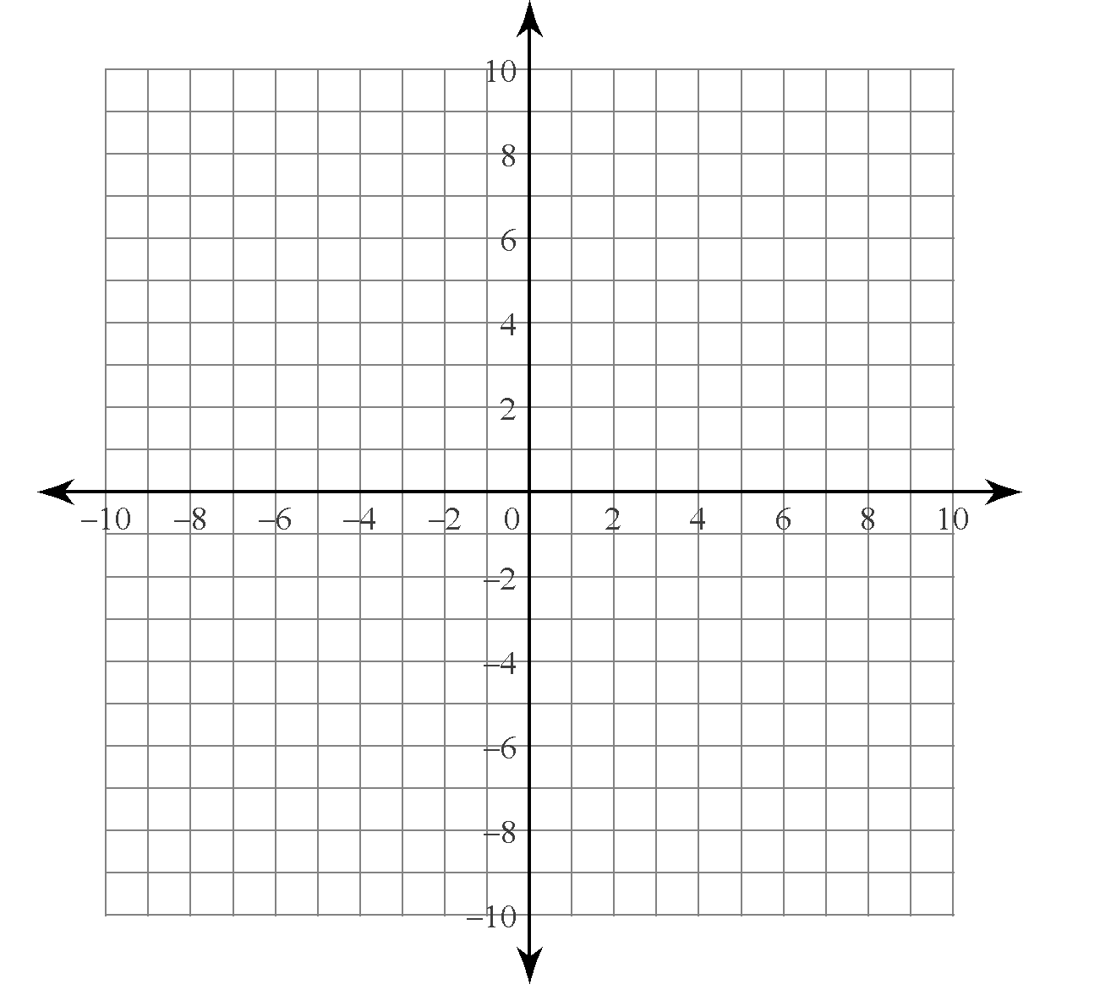

Domain – Range –

x-intercept – y – intercept –

asymptote – end behaviour –
$y=ab^{x}$ where a < 0

$y={-2}^{x}$ $y={-\frac{1}{2}\left(2\right)}^{x}$
$y={-2\left(2\right)}^{x}$ $y=-3{\left(\frac{1}{2}\right)}^{x}$

Domain – Range –

x-intercept – y – intercept –

asymptote – end behaviour –

