4.3 Analyzing Logarithmic Functions (continued)

Logarithmic Function –

$$y=a\log_{b}{x}$$

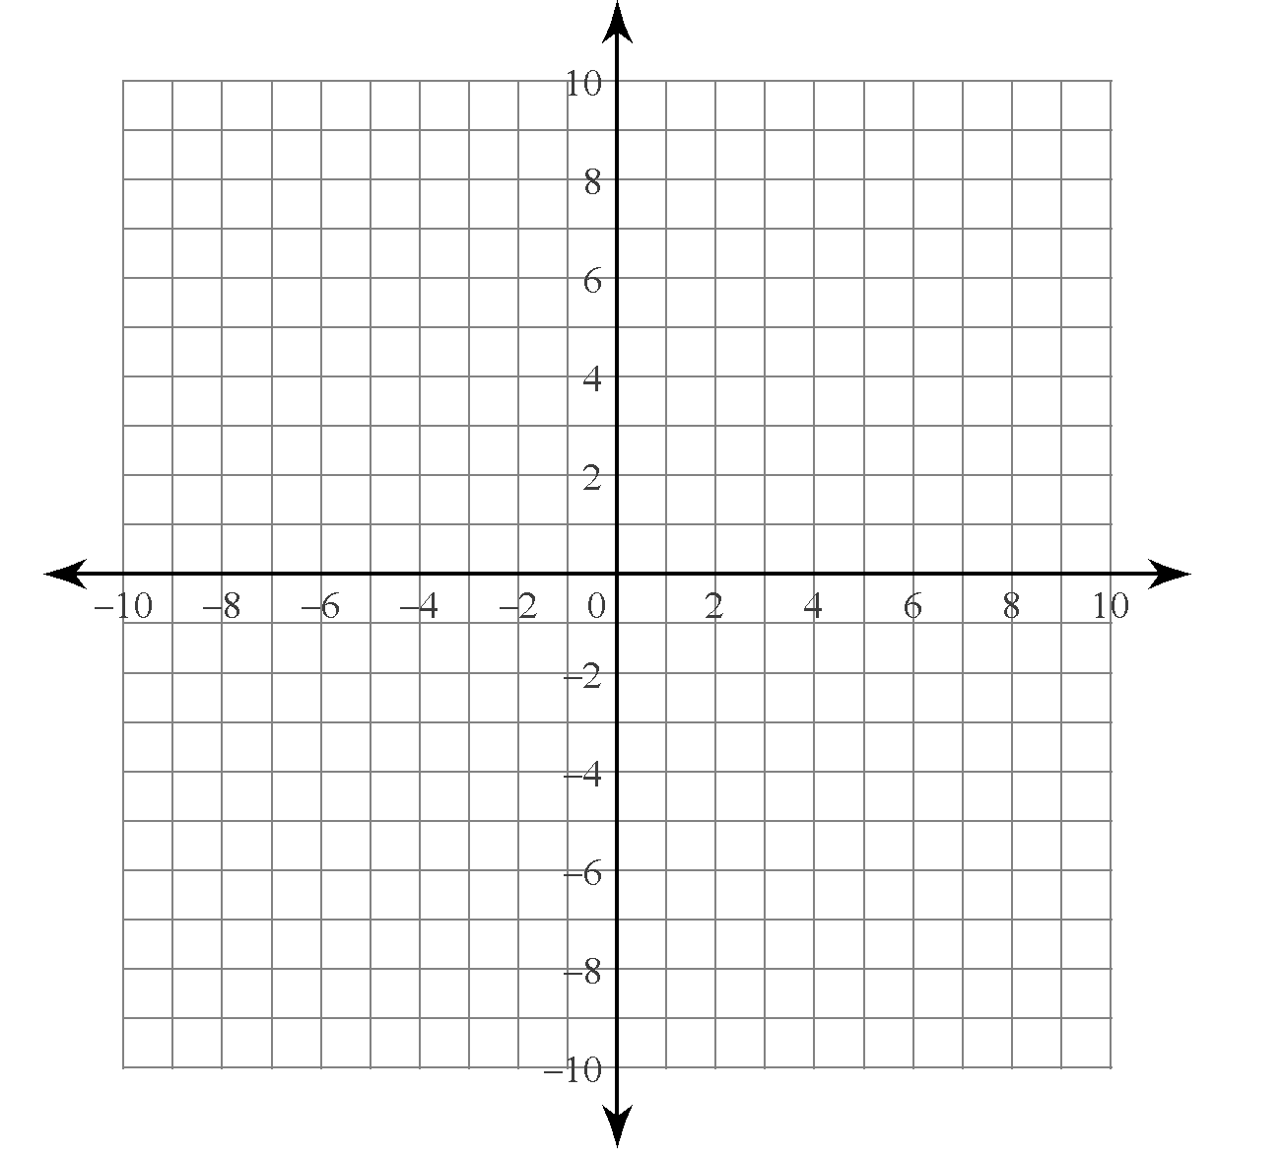
Effect of changing “b”

$y=\log_{2}{x}$

$y=\log_{4}{x}$

$y=\log_{\frac{1}{2}}{x}$

Common Logarithms –

Natural Logarithms –

Effect of changing “a”

$y=1\log_{2}{x}$

$y=2\log_{2}{x}$

$y=-2\log_{2}{x}$

$y=\frac{1}{2}\log_{2}{x}$

$y=-\frac{1}{2}\log_{2}{x}$

Domain – Range –

x-intercept – y – intercept –

asymptote – end behaviour –

