**4.6 Reciprocal Functions**

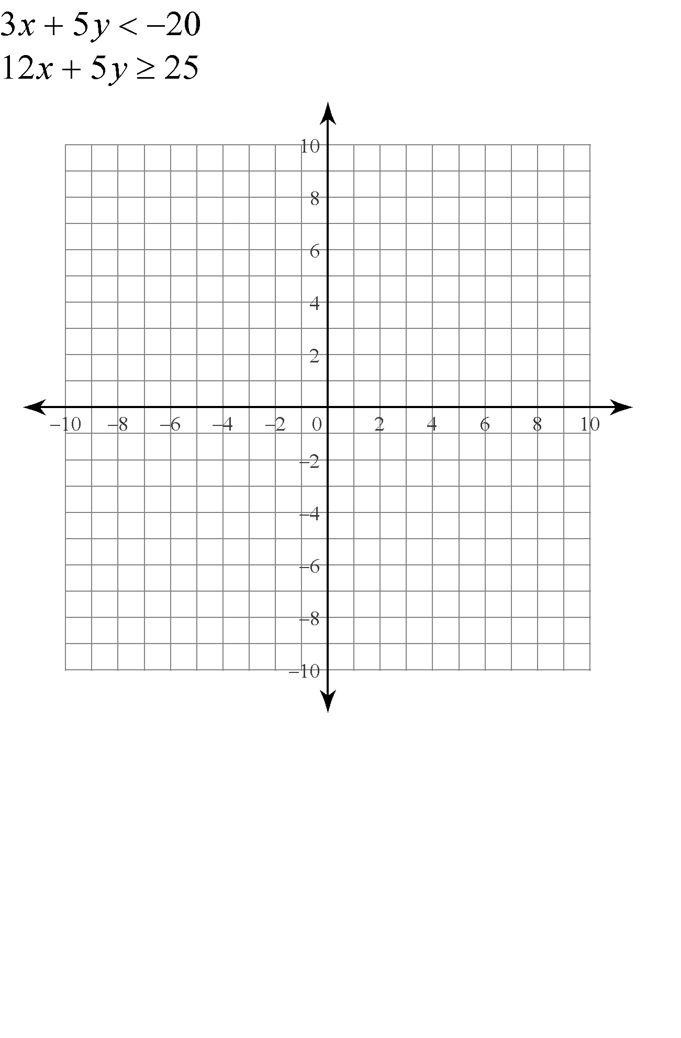

**Asymptote –**

**Steps to graph **

**Graph **

**Given the graph y =, graph y = f(x)**

