PreCalculus 10
Chapter 5 Practice Test
- Determine the slope of each line.
a) b)
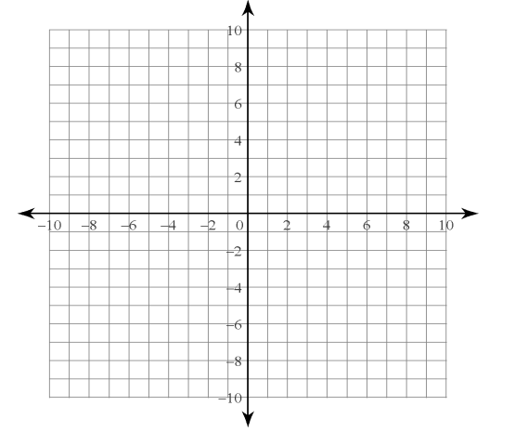

- Use the slope formula to determine the slope of the line passing through each pair of points.
- $\left(2, 4\right), \left(9, 8\right)$

- $\left(-2, -5\right),\left(1, -7\right)$

- $\left(-9, 16\right), \left(-9, 25\right)$

- Graph each line, given a point on the line and its slope.
- $\left(5, -3\right), m=-4$

- $origin, m=\frac{1}{4}$

- $\left(4, 0\right), m=undefined$

- a) Create a graph showing the melting of a 75-cm-high snow bank in spring. Plot the height, in centimetres, of the snow bank on the vertical axis and time, in days, on the horizontal axis, draw a segment with a slope of -3, with one endpoint at $\left(0, 75\right)$ and the other endpoint along the horizontal axis.

b) What does each point on the graph represent?

- What does the endpoint along the horizontal axis represent?

d) Explain the meaning of the slope in this situation.

- In 1800, the wood bison population in North America was estimated at 168 000. The population declined to only about 250 animals in 1893. This year, Wood Buffalo National Park was established on the Alberta/Northwest Territories border. In 2006, there were about 5600 bison in the park.
- What was the average rate of change in the bison population from 1800 to 1893? Describe the meaning of this rate.

- What was the average rate of change in the bison population from 1893 to 2006? Describe the meaning of this rate.

- Since the speed of light is faster than the speed of sound, you see lightning before you hear the sound of the thunderclap. If a thunderstorm is 110 m away, the sound of thunder is heard in $3.2 s$. If the storm is 4950 m away, the sound reaches you in $14.5 s$.
- Determine the average rate of change, to the nearest metre per second.

- What does this rate of change represent?

- If you hear thunder $30 s$ after you see lightning, how far away is the storm.

- For a line with each slope, state the slope of a line parallel to it. What is the slope of a line perpendicular to it?
- $m=5$ b) $m=-\frac{1}{3}$

- $m=0.5$ d) $m=0$

- Consider the line joining points $P\left(-6, 9\right)$ and $Q\left(-2, 1\right)$.
- What is the slope of a line parallel to this line?

- What is the slope of a line perpendicular to this one?

- For each pair of slopes, what is the value of $n$ if the lines are parallel? What is the value of $n$ if the lines are perpendicular?
- $\frac{n}{10}, 2$ b) $\frac{24}{n}, -\frac{1}{3}$

- Line $L_{1}$ passes through points $P\left(n, 4\right)$ and $Q\left(1, -2\right)$. Line $L_{2}$ passes through points $R\left(4, 3\right)$ and $S\left(1, 5\right)$.
- What is the value of $n$ if the lines are parallel?

- If the lines are perpendicular, what is the value of $n$?

