**6.0 Review of Trigonometry (part 2)**

**Trigonometric Equations:**

**Two types of solutions:**

Solve the equation , a) for  b) general form

Solve the equation , a) for  b) general form

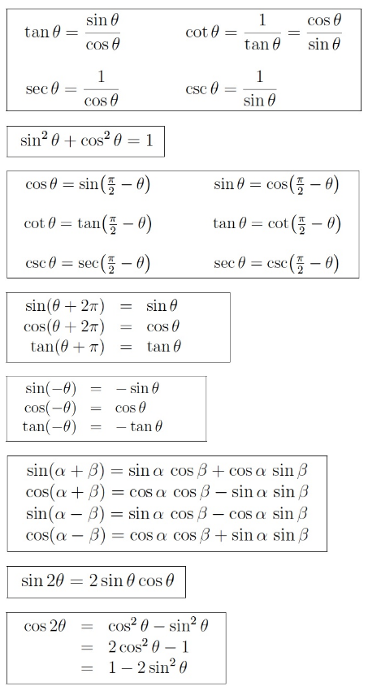

Prove:  