**6.1 Different Forms of Linear Equations**

There are three different forms of linear equations that you need to learn:

1. **Standard Form**

Switch the following into standard form:  
  

Graph the following standard form equations:

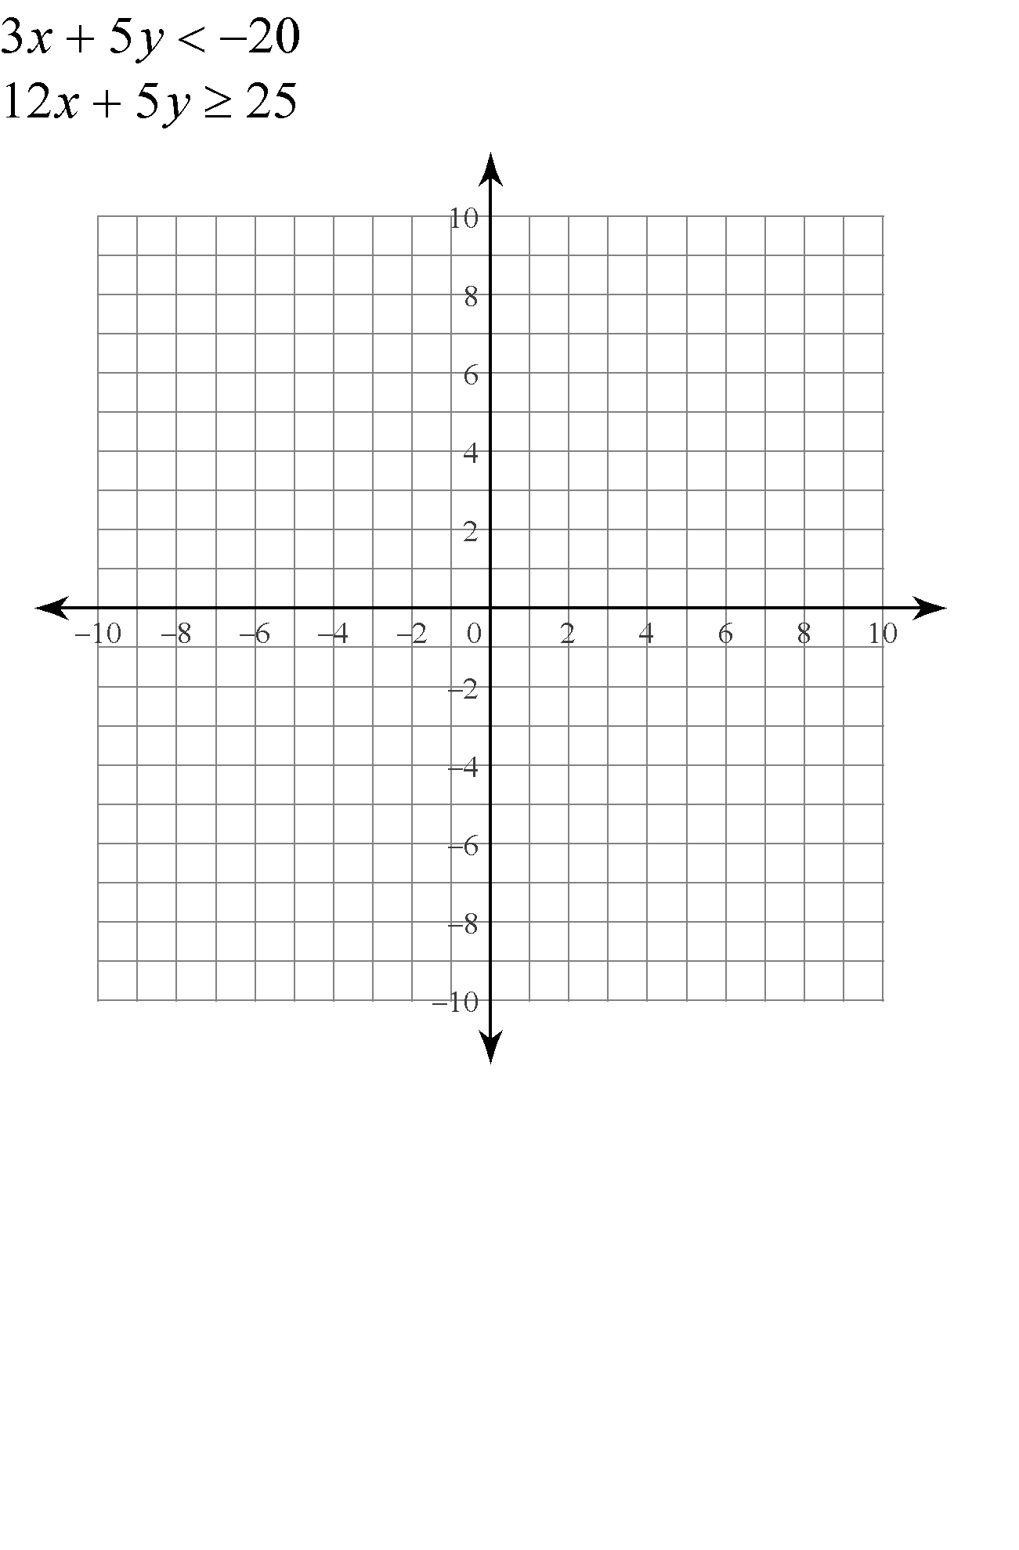 

1. **Slope-Intercept Form**

Switch the following into slope-intercept form:

  

Graph the following slope-intercept form equations:

   

