**6.1 Different Forms of Linear Equations (continued)**

There are three different forms of linear equations that you need to learn:

1. **Standard Form**
2. **Slope-Intercept Form**

1. **Point-Slope Form**

Graph the line that has a slope of  and passes through the point 

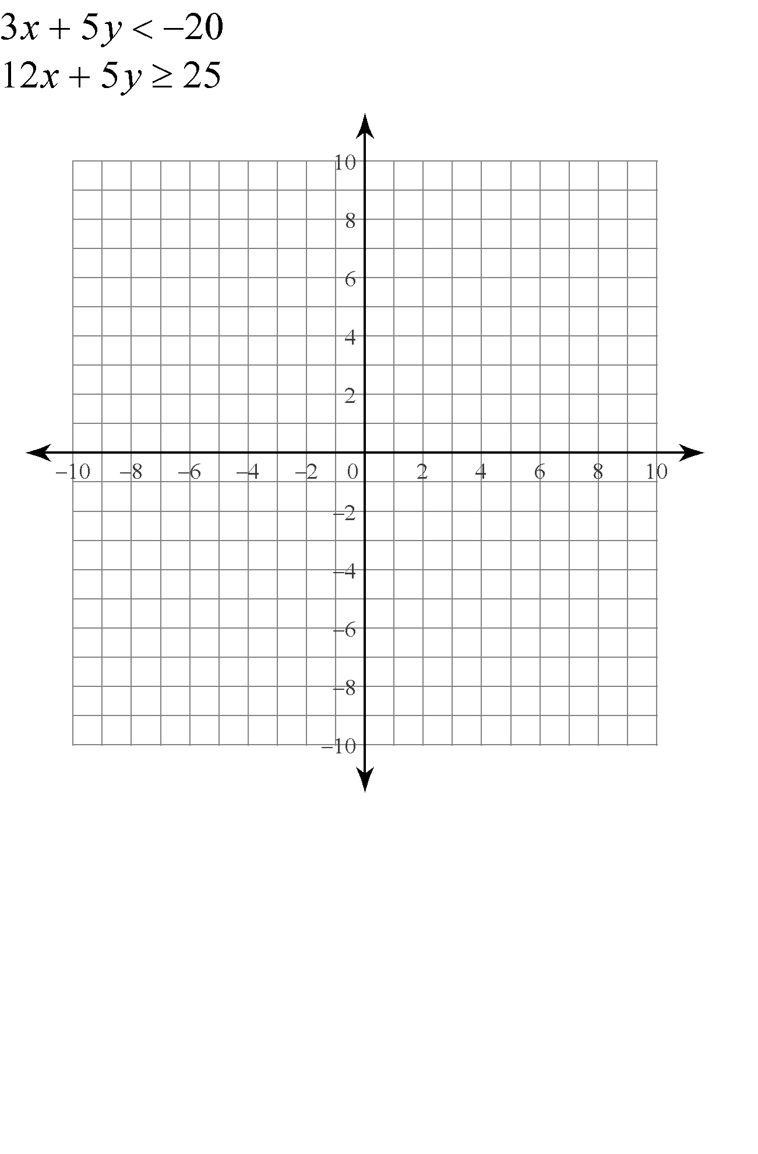Graph the equation in point-slope form: 

Rewrite in slope-intercept form: 

Rewrite in standard form: 

Write the equation of a line with slope 4 that passes through 

Write the equation of a line that passes through  and 

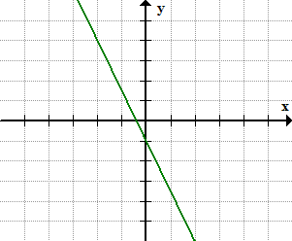Write the equation of the following line in all three forms:

**Slope-intercept form:**

**Standard form:**

**Point-Slope form:**