7.1 Properties of Quadratic Functions (part 1)

Quadratic Functions:

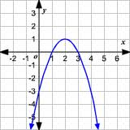

y – intercept:

x – intercept:

Vertex:

Axis of Symmetry:

Domain:

Range:

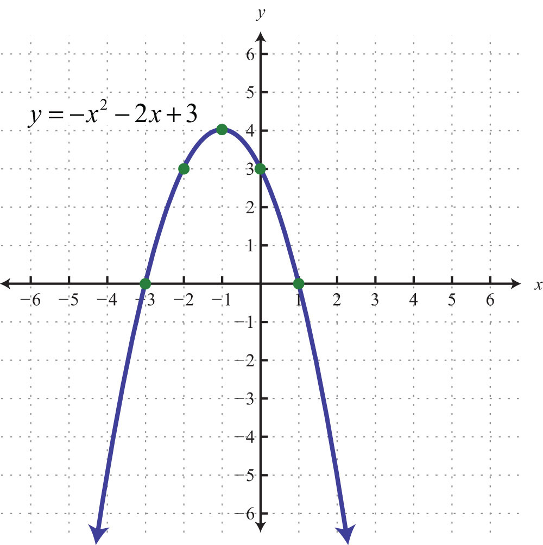
Vertex

Axis of Symmetry

y-intercept

x-intercept

Domain

Range

Minimum or Maximum?

