**7.3 Derivatives of Other Trigonometric Functions**

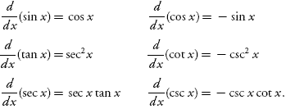

Prove:  

Differentiate:  

 

If , then find 

Find the equation of the tangent line to  when 