**7.5 Inverse Trigonometric Functions**

**Inverse Functions –**

 

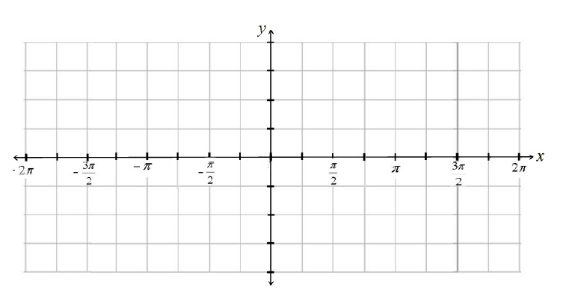

Domain: Domain:

Range: Range:





Domain: Domain:

Range: Range:

 

Domain: Domain:

Range: Range:

**Find the exact value of the following:**

   

   

   