**8.0 Review of Logarithms**

**What is the inverse of an Exponential Function?**

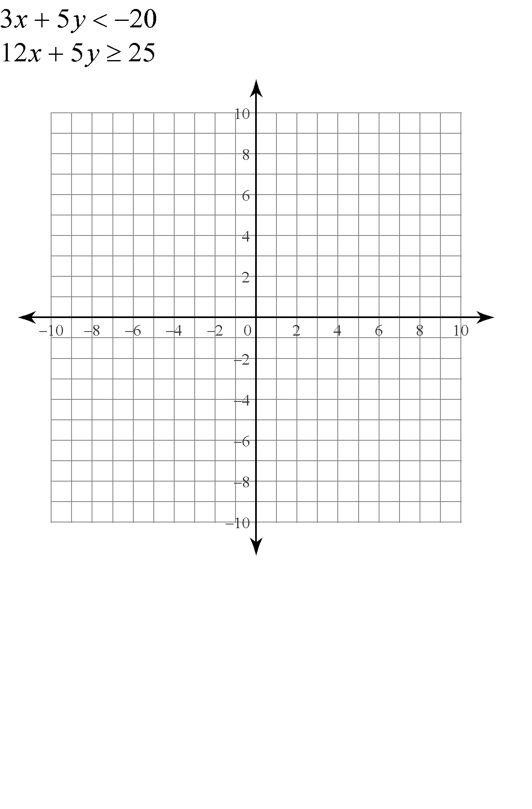

$y=2^{x}$

**Logarithmic Function –**

Write the following exponential statements in logarithmic form:

$5^{4}=625$ ${81}^{\frac{1}{2}}=9$

Write the following logarithmic statements in exponential form:

$\log_{3}{243}=5$ $\log_{2}{\frac{1}{8}}=-3$

In each case, express the logarithmic equation as an exponential equation and solve for the variable:

$\log_{4}{x=3}$ $\log_{64}{x=\frac{1}{6}}$

$\log_{b}{27}=3$ $\log_{b}{5}=\frac{1}{3}$

$\log_{2}\left(\frac{1}{4}\right)=y$ $\log_{8}{2}=y$

**Laws of Logarithms**

Use the laws of logarithms to rewrite the following:

 

Express  as a single logarithm