**8.3 Logarithmic Functions**

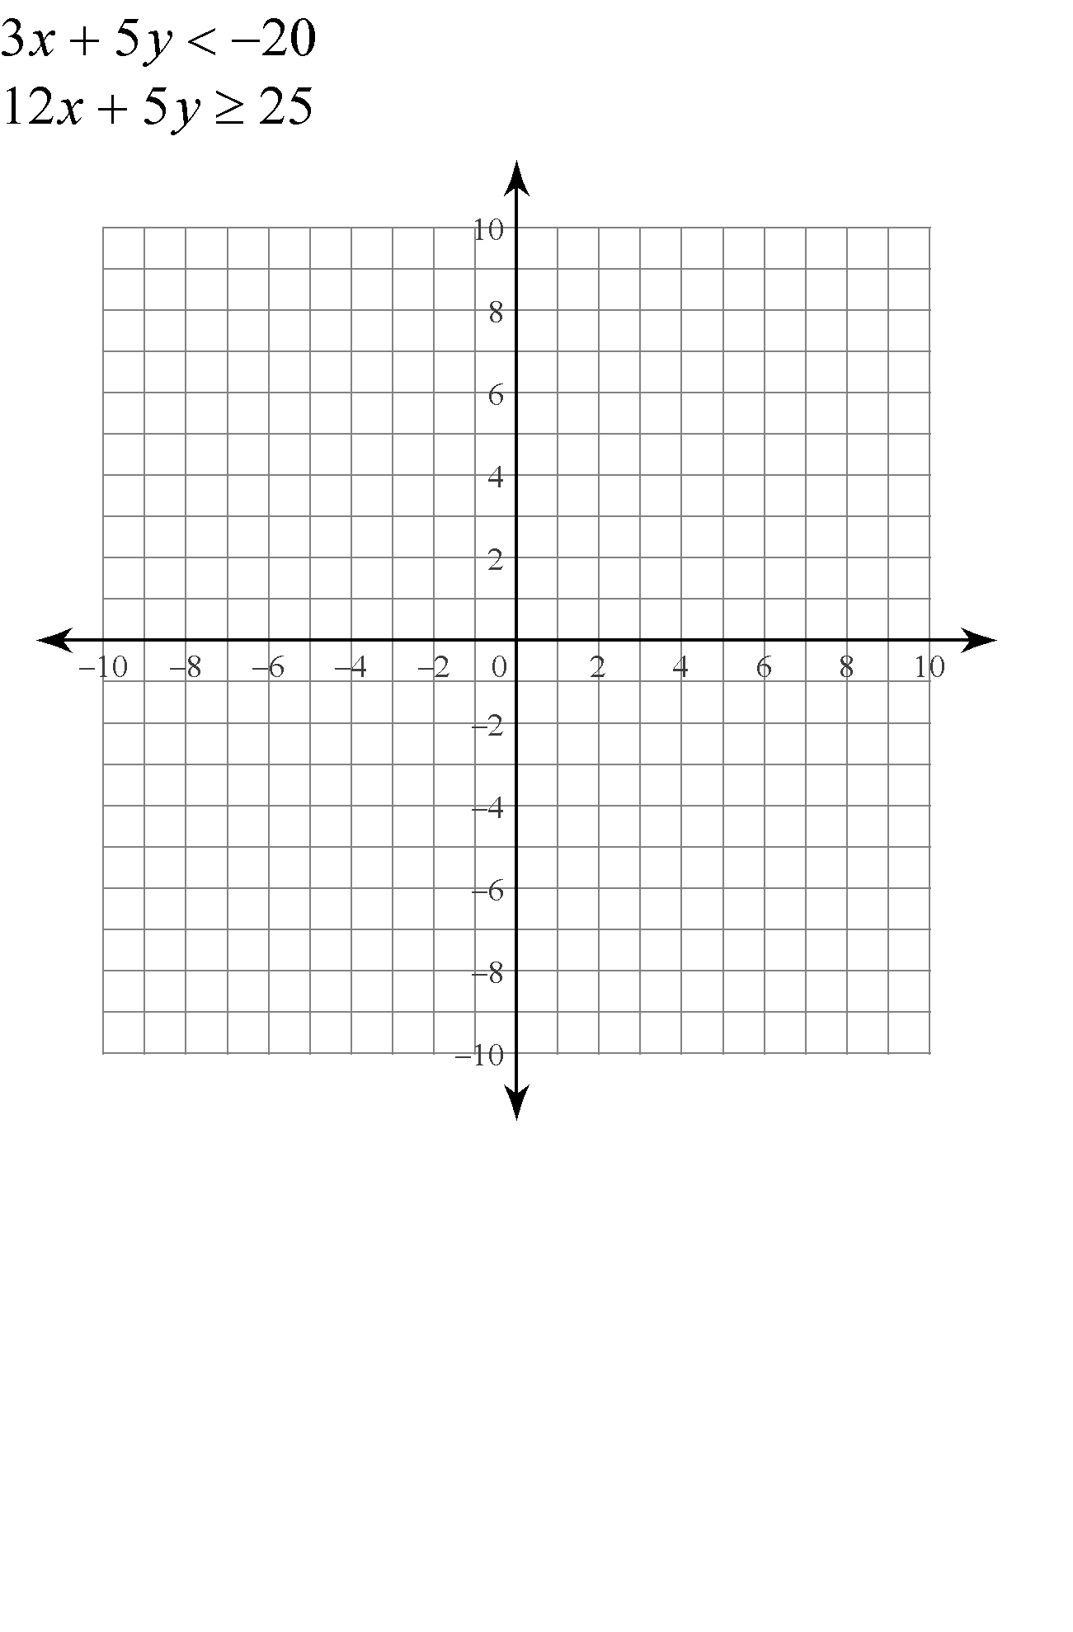

$y=\log_{2}{x}$

$y=\log_{4}{x}$

$y=\log_{\frac{1}{2}}{x}$

Domain – Range –

*x*-intercept – *y* – intercept –

asymptote – end behaviour –

**Common Logarithms –**

**Natural Logarithms –**

Find the domain of the function  and sketch its graph.

Solve the equation 

Find 