Graphing Reciprocals of Linear Functions
Sketch each pair of functions on the same graph (use different colours if possible). You may want to make a table of values to help you:
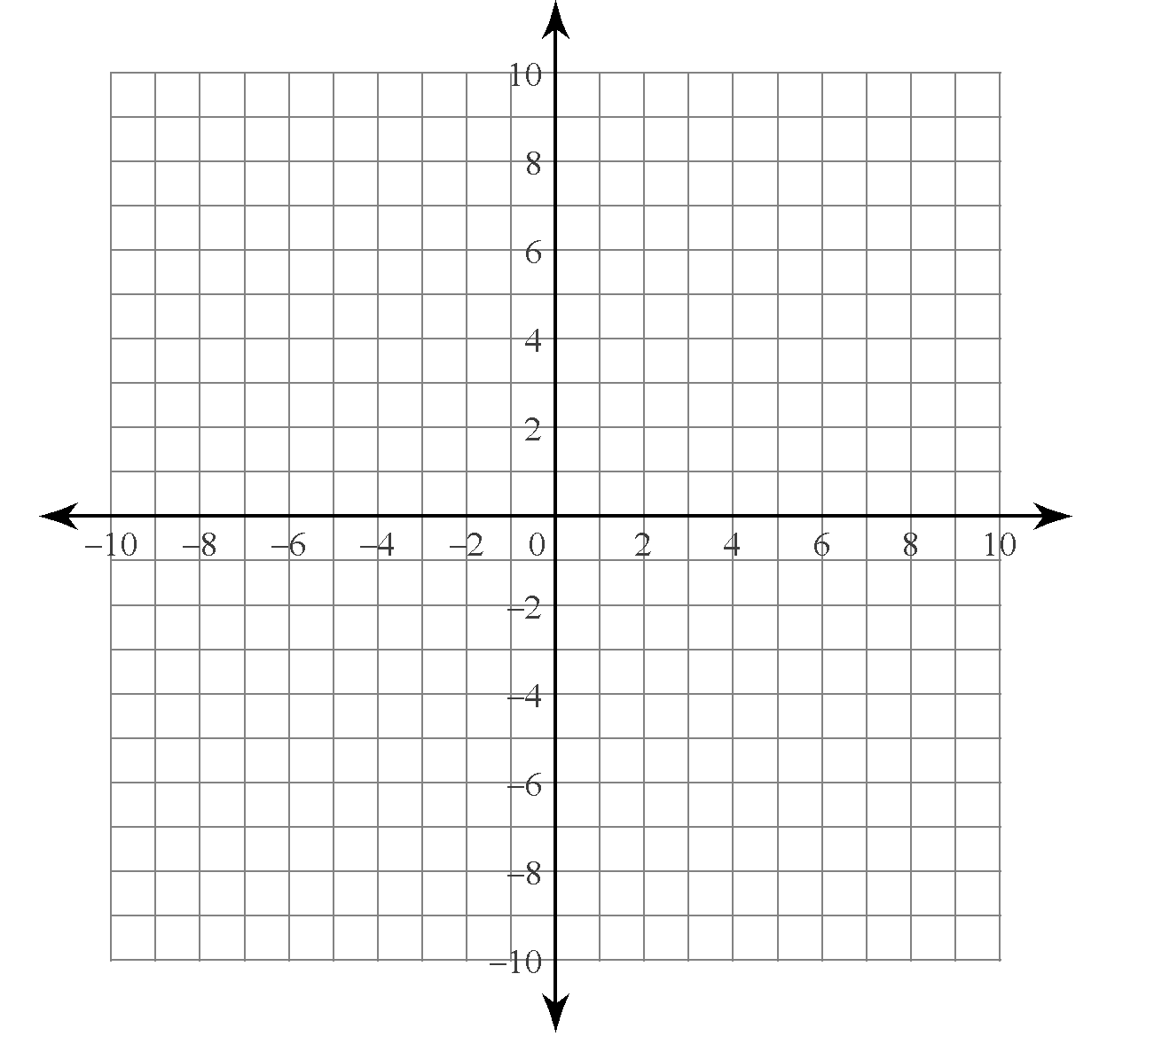
1) $y=x$
$y=\frac{1}{x}$

X | -5 | -2 | -1 | -0.5 | -0.2 | -0.1 | 0 | 0.1 | 0.2 | 0.5 | 1 | 2 | 5
$$y= \frac{1}{x}$$

2) $y=2x-6$
$y= \frac{1}{2x-6}$

X
$$y= \frac{1}{2x-6}$$

