Graphing Reciprocals of Quadratic Functions

Last day we learned that reciprocal functions of the form $y= \frac{1}{f\left(x\right)}$ have vertical asymptotes wherever ______________________________________________
With that in mind, how many vertical asymptotes can the reciprocal of a quadratic functions have? __________________________________

Graph the following reciprocal functions. Do NOT use a table of values. Graph the quadratic function f(x) and use it to graph the reciprocal function $y= \frac{1}{f\left(x\right)}$

$y= \frac{1}{-x^{2}-1}$
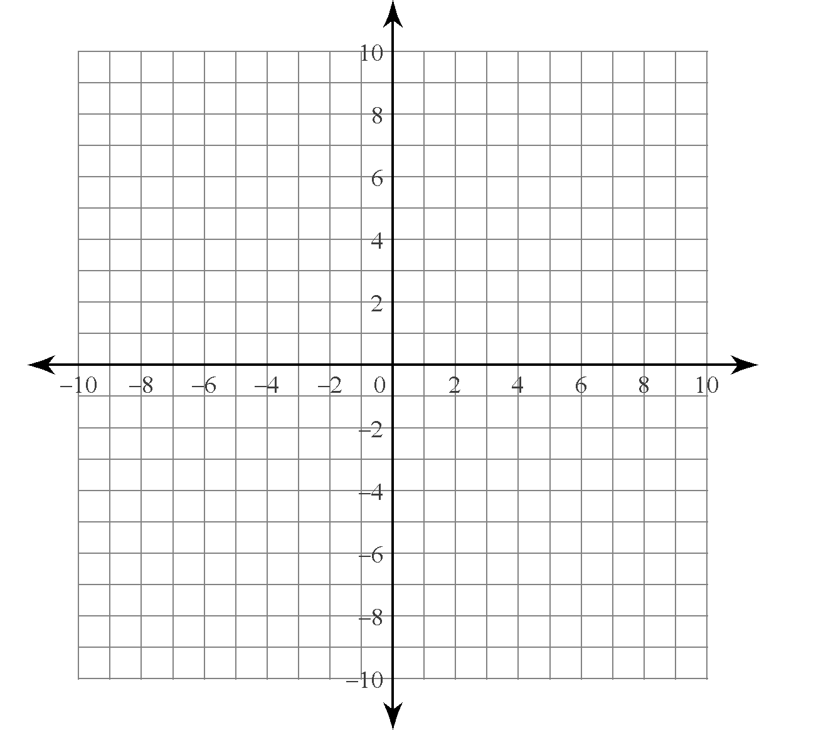

$y= \frac{1}{3{\left(x-1\right)}^{2}}$

$y= \frac{1}{x^{2}-4}$

