Absolute Value Functions

Sketch each pair of functions on the same graph (use different colours if possible). You may want to make table of values to help you:
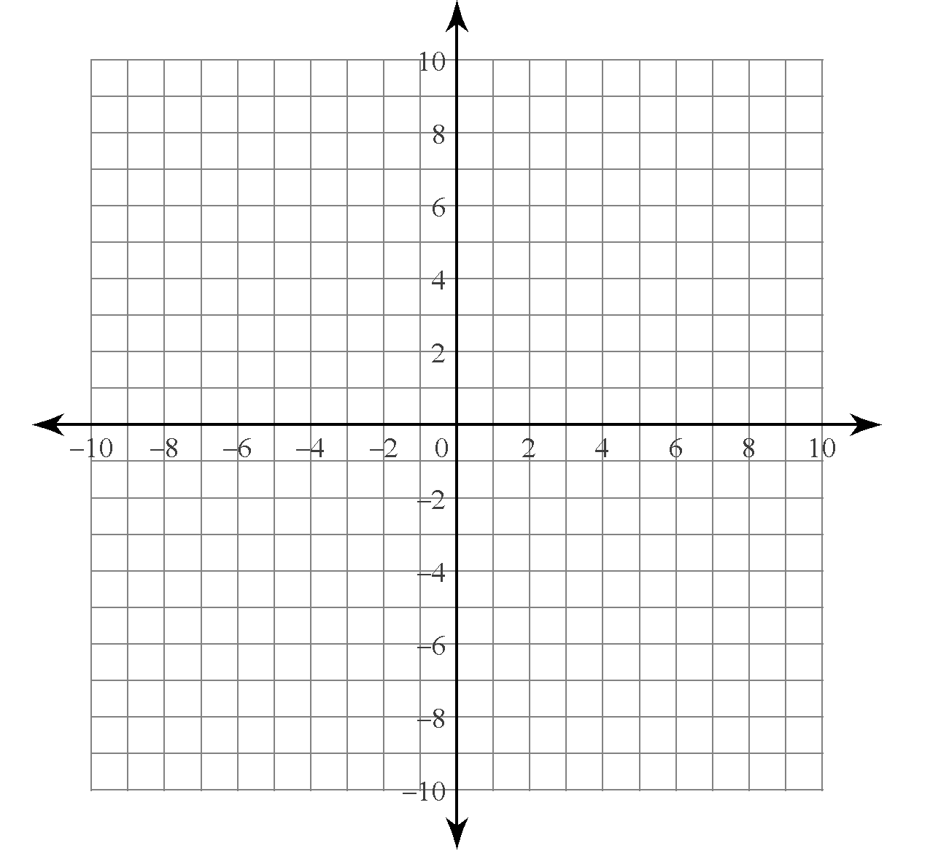
1) $y=x$
$y= \left|x\right|$

(the “mother functions”)

2) $y=2x-6$
$y= \left|2x-6\right|$

3) $y=2{\left(x+1\right)}^{2}-2$
$y=\left|2{\left(x+1\right)}^{2}-2\right|$

4) $y= -{\left(x-3\right)}^{2}-2$
$y= \left|-{\left(x-3\right)}^{2}-2\right|$

