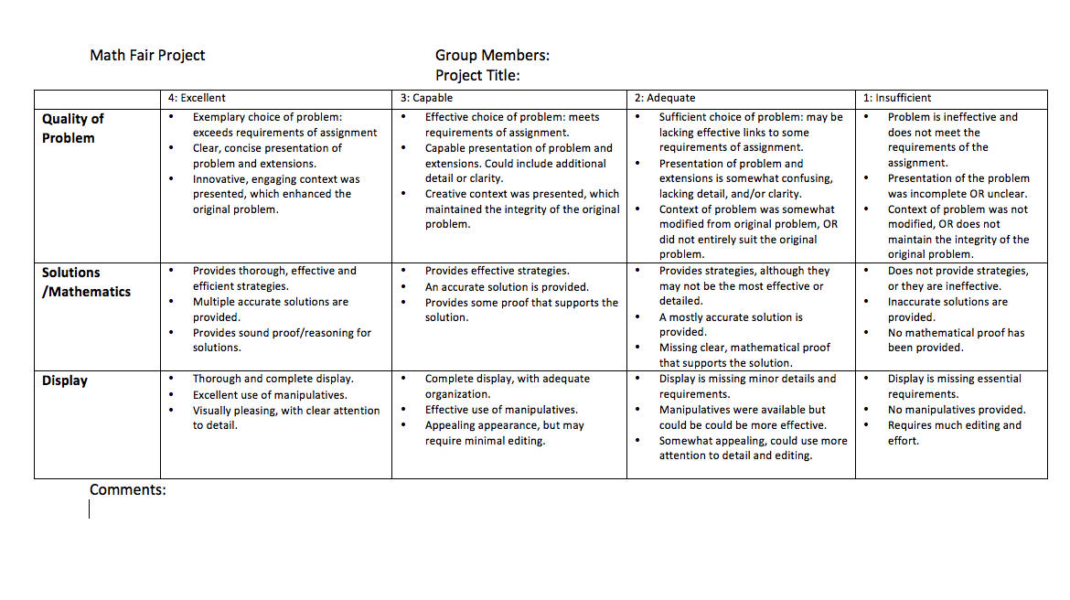

* Check out www.mathfair.com for lots of ideas and explanations

