MYP Math Assessment:  Problem Solving Assignment #1 |  |  | Year 4
 |  |  | MYP Unit 1
Student Name: |  | Date:
MYP Criterion B Level |  | MYP Criterion C Level

ASSESSMENT CRITERIA
Achievement Level | Criterion B (Investigating Patterns) | Criterion C (Communications) | Task Descriptors
8  7 | - select and apply mathematical problem-solving techniques to discover complex patterns  - describe patterns as relationships and/or general rules consistent with correct findings  - verify and justify these relationships and/or general rules. | - consistently use appropriate mathematical language  - use different forms of mathematical representation to consistently present information correctly  - move effectively between different forms of mathematical representation  - communicate through lines of reasoning that are complete and coherent  - present work that is consistently organized using a logical structure. | - All answers provided are clear and easy to understand  - Student uses appropriate mathematical language and/or diagrams  - Work shown is very organized and uses a logical structure  - Student provides valid reflection and rationale for whether their answer seems correct or not  - Problems are solved using multiple methods  - Problems are extended and solved correctly
6  5 | - select and apply mathematical problem-solving techniques to discover complex patterns  - describe patterns as relationships and/or general rules consistent with findings  - verify these relationships and/or general rules. | - usually use appropriate mathematical language  - usually use different forms of mathematical representation to present information correctly  - move between different forms of mathematical representation with some success  - communicate through lines of reasoning that are clear although not always coherent or complete  - present work that is usually organized using a logical structure. | - All answers provided are clear and easy to understand  - Student uses appropriate mathematical language and/or diagrams  - Work shown is well organized and uses a logical structure  - Student provides valid reflection and rationale for whether their answer seems correct or not  - Attempts to solve problems using multiple methods
4  3 | - apply mathematical problem-solving techniques to discover simple patterns  - suggest relationships and/or general rules consistent with findings. | - use some appropriate mathematical language  - use different forms of mathematical representation to present information adequately  - communicate through lines of reasoning that are able to be understood, although these are not always clear  - adequately organize information using a logical structure. | - Answer provided with some clarity  - Work is shown though not always easy to understand and/or with some errors  - Work shown is neat and organized with some logical structure  - Student provides some reflection and rationale for whether their answer seems correct or not
2  1 | - apply, with teacher support, mathematical problem-solving techniques to discover simple patterns  - state predictions consistent with patterns. | - use limited mathematical language  - use limited forms of mathematical representation to present information  - communicate through lines of reasoning that are difficult to interpret. | - Answer provided but with lack of clarity  - Work shown is incomplete, missing steps, or completely incorrect  - Answer provided but with significant assistance from teacher  - No reflection and/or rationale for answers provided  - Work shown is disorganized and/or difficult to understand
0 | - The student has not reached a standard described by any of the descriptors given above. | - The student has not reached a standard described by any of the descriptors given above. | - Assignment meets none of the requirements or was not handed in

NOTE: Criterion C will be assessed based on a collection of short answer and written responses.

Problem Solving Assignment
There are four parts to this assignment (and we will do one assignment of this type in each of the three terms this year). These assignments will be marked in the Patterns Criteria (Criteria B), as well as the Communication Criteria (Criteria C).
Part 1
You will be given a list of approximately ten problems. You will be given a number of weeks to solve three of these problems and to write up your solutions (a rubric will be provided). You can ask other students for help with these problems. You can also ask your math teachers (though don’t expect us to just “give” you the answer). However, it is very important that you come to your own understanding of how to solve your three problems.
Ideally, it would be great if you were able to solve some of the problems on your own this year – this will give you that amazing “WOW! I DID IT!” feeling that is the very best part of doing Math. Whether you solve the problems yourself or with the assistance of others, you must do your own, original write-up of the solutions. DO NOT PLAGIARIZE!

Part 2
Before the three problems are due, there will be opportunities for students to orally present one of their solutions to the class (a rubric will be provided). Every student in the class must do one presentation this year. If you find a problem you like / understand, you may want to come let me know right away… only one person gets to do each problem (no repeats).
On the day that the three problems are due, you will hand in your solutions (obviously) and then…
Part 3
I will randomly choose one of the exact same three problems for you to solve again on a separate piece of paper. I know this seems redundant (if not stupid) but I am hoping that this will help me discourage copying (with absolutely no understanding) of solutions between students (as has been a problem in the past).
Part 4
You will then be given three new problems. You will need to (try) to solve one of these three problems in class time with no assistance from others. I know this is a bit scary but I will make the problems slightly easier than the original list of ten questions. And, hey, this is only one of four parts. You have lots of other ways to show understanding / growth.

Problem Set #1

- A gorilla, 2 orangutans, and 3 men have to cross a river in a canoe. The canoe can carry two. The gorilla can paddle but the orangutans can not. If the number of apes on one side of the river outnumbers the men then the apes will kill the men. How do you get everyone across the river?
- On your travels you come to an old man on the side of the road holding three cards from a standard deck face down. Trying to make conversation you ask him what the three cards are.
He tells you, "To the left of the queen, are one or two jacks. To the right of the jack, are one or two jacks. To the right of the club, are one or two diamonds. To the left of the diamond, are one or two diamonds." What are the three cards? (Find 2 – or even 3! – different solutions)
- You have 45 watermelons that you need to take to market. The market is 15 km away and you can only carry 15 watermelons. The road you need to travel is a toll road and the toll is one watermelon per km. How many watermelons can you get to market (you can stash watermelons along the way)?
- What 5-digit number has the following features:
If we put the numeral 1 at the beginning, we get a number three times smaller than if we put the numeral 1 at the end of the number.
- ABCD is a rhombus (opposite sides parallel and all 4 sides same length).
Point H is on BC and Point K is on CD such that AB = AH = HK = KA. Determine the measure of ∠BAD.

- At present, the sum of the ages of a father and his son is 43 years. In n years,
n > 0, the father will be four times the son's age.
Determine all the possible ages of the father and son.
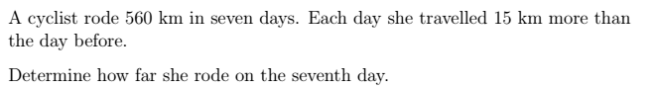

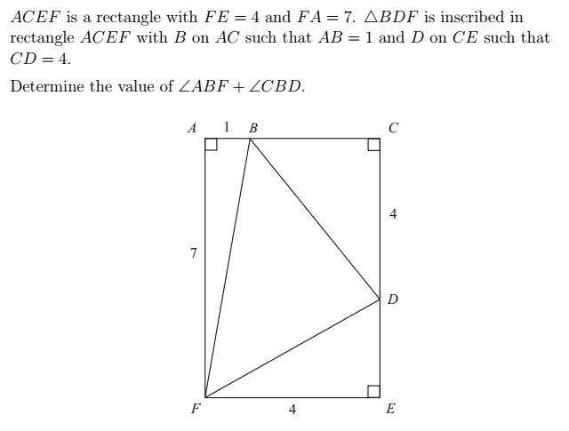
8.

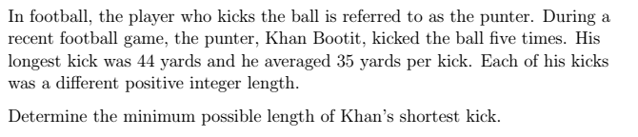
9.

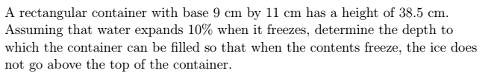
10.

11. In his will, a father left all of his money to his children in the following manner:
(i) $1000 to the oldest child plus $\frac{1}{10}$ of what remains, then
(ii) $2000 to the second oldest child plus $\frac{1}{10}$ of what then remains, then
(iii) $3000 to the third oldest child plus $\frac{1}{10}$ of what then remains, and so on.
After all of the money had been distributed, each child had received the same
amount. How many children were there?

